49
SWAN LAKE

HABITAT REHABILITATION AND ENHANCEMENT PROJECT

Pool 26
Illinois River Miles 5 - 13

Calhoun County, Illinois
St. Louis District

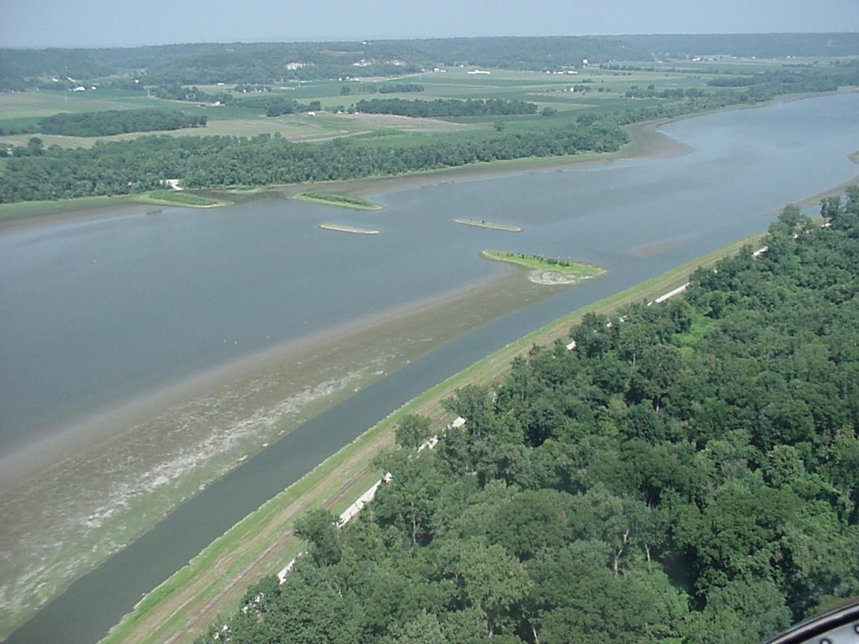

RESOURCE PROBLEM:

Current sedimentation rates indicate that 30% of the lake surface acreage will be lost over the next 50 years due to sediment-laden floodwaters entering from the Illinois River and from the 30-square-mile watershed adjacent to the west shore of the lake. This will result in a direct loss of wetland habitat for both waterfowl and fish. In addition, present water level fluctuations and wind-generated wave action impact the growth of aquatic plants and the quality of fisheries in the area.
PROJECT FEATURES:

- Construct a riverside dike/levee structure to retard the deposition of river induced sediment;

- Construct water and sediment control basins and ponds to trap hillside sediments;

- Construct a lake closure within Swan Lake proper;

- Upgrade an existing closure at the upper Swan Lake/Fuller Lake site for the compartmentalized control of interior water levels;

- Construct other water control structures (including gates and pumps) to provide for interior water level control and fish movement; and

- Dredge lake sediments to construct two barrier island groups to reduce wind-generated wave action and reduce turbidity levels within Swan Lake.

PROJECT OUTPUTS:

The project will increase overall habitat value for waterfowl and fish by substantially reducing future sedimentation, providing water level control, reducing wind induced wave action and turbidity, providing deeper water areas, and allowing for free movement of fish between the lake and river in late fall/early winter.

FINANCIAL DATA:

General design costs were $677,000, and construction costs are estimated at $7,854,000. In accordance with Section 906(e) of the 1986 Water Resources Development Act (Public Law 99-662), general design and construction costs for the hillside sediment control features would be shared on a 75% Federal/25% non-Federal basis. The remaining project features on Mark Twain National Refuge lands would be constructed at 100% Federal cost. The non-Federal sponsor, the Illinois Department of Natural Resources, would be responsible for 100% of the project’s annual operation, maintenance, and repair costs estimated at $60,000.

STATUS:

The project was approved for construction in June 1993. Construction completion is scheduled for September 2000. A Memorandum of Agreement between the Corps of Engineers and the Natural Resources Conservation Service has been signed for hillside sediment control measures.

